**Lecture 21: Cancer**

10801040 莊博恩、10801128 陳俊鴻

1. Lecture Notes

這次的這部分應該是我的組員負責，但距離上次提醒他過了好幾天他還是沒寄給我，所以我先寄給老師，等他寄給我，我再寄一次給老師。

1. Questions and Answers

Question 1:

植物得到癌症的機率有比動物得到癌症的機率高嗎？

Answer 1:

我認為是「植物得到癌症的機率比較高」，因為

1. 植物一般來說基因皆為多倍體，故我認為植物在細胞分裂及減數分裂上較容易產生錯誤，可能使子細胞的基因產生變異，進而導致癌細胞產生
2. 植物不具移動能力，也就是植物必須較動物面對較大的環境變異，例如：早晚氣溫變化，四季乾濕度變化等，不像動物可移動到環境比較適合自己的地方，甚至候鳥等動物還可以藉由遷徙等大規模移動來尋找適合自己的環境。

然而，經過查詢，發現植物得到癌症的機率是較低的，於是我想先從「造成動物癌症和植物癌症的機制是否相同」來判斷。

經查詢，有幾種方式可以造成植物的癌症(引發腫瘤形成)：

A、由病原體(pathogens)與共生體(symbionts)引起

Tumors通常不會殺死植物，但可以抑制植物的活力與阻礙植物的生理功能，例如嫁接等

以下為會干擾植物賀爾蒙的pathogens及symbionts：

1. Agrobacterium tumefaciens(根癌農桿菌,pathogens)，造成Crown gall tumours

桿菌質體的T-DNA(帶有形成癌症的必須基因)會被轉殖入宿主的染色體中，這些基因會改變植物中auxin與cytokinin的含量，導致植物的aberrant cell proliferation, vascularization等，以提供一個良好的環境給Agrobacterium tumefaciens。

The T-DNA integrates into the host genome and carries genes that are essential for tumour formation9. These genes alter the levels of the plant hormones auxin and cytokinin in the host, and can lead to aberrant cell proliferation, complex changes in transcription, physiology10 and vascularization11,12, which produces an ideal habitat for the pathogen. [1]

1. Rhizobium(根瘤菌,symbionts, 可以形成nodule)，能誘使tumor產生

原因為宿主和symbiont間的aberrant signaling，使宿主cytokinin receptor的突變，進而導致spontaneous nodule formation，因為將cytokinin的基因轉殖入nonnodulating的細菌也會導致nodule形成，因此cytokinin被認為能促進cell proliferation during nodule formation，而細胞大量分裂有可能會導致癌細胞產生，故Rhizobium造成的cytokinin receptor突變被認為可能和tumor形成有關。

Rhizobium — a genus of nitrogen-fixing symbionts related to Agrobacterium that normally induces the formation of organized nodules on the roots of compatible leguminous hosts — can induce tumours with disorganized tissues if inoculated onto the roots of related but incompatible legumes.

it seems highly likely that they result from aberrant signaling between the host and prospective symbiont. Mutations in the host cytokinin receptor can lead to spontaneous nodule formation, and the introduction of cytokinin biosynethic genes into a nonnodulating strain of bacteria can induce the formation of nodules in suitable hosts. These observations emphasize the central role that cytokinin has in activating cell proliferation during nodule formation and suggests a possible evolutionary relationship between symbiont-controlled organogenesis and the pathogen-induced tumours. [1]

另外，Rhodococcus fascians (一種放線菌)、Ustilaginales(一種真菌)也會以干擾賀爾蒙的方式來誘發tumors形成。

B、病毒感染造成腫瘤形成(用和賀爾蒙沒有關的方式)

藉由host–virus combination, induce tumours by directly interfering with

cell cycle regulation, RBR pathway

Viral infections can also cause neoplasia and tumour-like growths known as enations, through hormone-independent mechanisms. The geminiviruses, a group of double-stranded DNA viruses, use the host DNA replication machinery and, depending on the host–virus combination, can seriously perturb normal development and lead to tumour-like outgrowths in the most severe cases. [1]

Geminiviruses病毒和上述細菌、真菌的差別為其並不是透過干擾賀爾蒙誘發tumor，而是透過影響RBR pathway來干擾cell cycle regulation

但並不是所有的病毒都和干擾賀爾蒙無關，例如Beet Curly Top virus也可以造成癌症，但其作用就是透過hormone responses

C、最後，在某些特定植物上(particularly interspecific hybrids in certain genera)，tumor會很容易在沒有病原體的侵入下自己產生，例如Nicotiana (tobacco)，而其內部造成tumor形成的干擾機制也和賀爾蒙有關(hormone dysfunction)，因為其組織可以在不需要exogenous hormones下成長，和growth factor-independent mammalian cancer cells相似。

而為什麼tobacco會特別容易自己產生tumor？目前認為可能和T-DNA genes的ancient horizontal transfer有關，使植物失去正常調控的基因表現的能力。

Why tobacco should be so susceptible to genetic tumours is uncertain, but an ancient horizontal transfer of T-DNA genes from an Agrobacterium-like species has been suggested as a possible factor. Perhaps the relatively recent introduction of prokaryotic genes into the plant genome means that their expression is poorly regulated in the hybrids. [1]

故我自己認為植物細胞和動物細胞不同的地方應在於：

1. 動物的癌症形成主要是自己的基因突變造成，和外在的病原體較無關係，然而植物卻相反，許多病原體(包括病毒、細菌、真菌)都可以誘發tumor形成，反觀只有特定種植物的癌症才會和外來病原體的侵入無關。
2. 從分子機制上來說，動物癌症的形成似乎和激素調控失常較無關，然而在植物中賀爾蒙失常卻是植物癌症形成的一大原因(除了geminiviruses是干擾RBR pathway，和賀爾蒙無關)。

那在這些機制的差異下，植物為何比動物有更少機率得到癌症？

因為(2)提到植物的癌症成因是因為hormone及RBR pathway的干擾，故先從這兩者開始探討：

Intercellular signaling pathways control the location and extent of plant cell proliferation. The signals controlling plant development, however, are profoundly different, and plants lack genes that are related to those of typical animal developmental signaling pathways such as the Sonic Hedgehog and wnt or Decapentaplegic (Dpp) pathways. Instead, the signals that are most often

used to coordinate functions across cells and tissues are plant-specific hormones

such as auxin, cytokinin, gibberellin and brassinosteroids. [1]

和動物細胞相同，植物細胞透過signaling pathway控制著細胞分裂的位置與程度，然而，植物細胞缺少很多調控的重要基因，例如Sonic Hedgehog、Dpp等，植物主要是透過plant-specific hormones像auxin, cytokinin, gibberellin and brassinosteroids做為信號來coordinate functions across cells

其中，auxin and cytokinin是植物中常見的激素，能促進細胞分裂，功能如下：

auxin and cytokinin have been most often implicated in stimulating cell division.

Like animal mitogens, auxin can activate gene expression in a concentration-dependent manner and so can be translated into graded cellular responses, coordinating proliferation across an organ. Auxin binds directly to an F-box receptor protein, TRANSPORT IMHIBITOR RESPONSE 1 (TIR1), leading to the degradation of specific auxin- or INDOLE‑3‑ACETICACID (IAA)-induced repressor proteins and the release of sequestered (and therefore inactive) transcription factors. The

effects of auxin on cell division are probably mediated by auxin-regulated transcription factors such as the PLETHORA proteins. [1]

Auxin就像動物中的mitogens，可以促使基因表現，並調控分裂與增生，主要機制為auxin與F-box receptor結合後，可以使repressor proteins分解並釋放transcription factors，如下方(FIG. 1)中的PLETHORA proteins就是auxin-regulated transcription factors。

Cytokinin binds to a histidine kinase, inducing tumour-like growth (or callus) in culture. Plants with reduced levels of cytokinin (owing to mutations in iosynthetic genes or defects in cytokinin perception) are smaller owing to reduced cell proliferation. Conversely, either overexpression of cytokinin biosynthetic genes or enhanced perception leads to increased cell proliferation. The cytokinin signal connects to the core cell division control through cyclin D. Members of the cyclin D family are essential for the cytokinin response in Arabidopsis, as their overexpression permits cytokine in independent callus formation, and cyclin D-knockout mutants are resistant to cytokinin. The cyclin D family interacts with the RBR pathway that, as mentioned above, is also a key target for pathogens that cause plant tumours. [1]

Cytokinin則可以和histidine kinase結合並導致tumour-like growth，故cytokinin表現少則會減少proliferation，反之亦然。Cytokinin會藉由釋放cyclin D並經過RBR pathway來控制細胞分裂，如下方(FIG. 1)。

(FIG. 1)

In the context of plant tumorigenesis, it is interesting to note that when pathogens

cause tumours by manipulating hormone responses, they seem to primarily alter auxin and cytokinin synthesis. [1]

由一開始的pathogens介紹可以得知，影響hormone功能的pathogens主要都是藉由控制auxin and cytokinin synthesis來引發癌症，故hormone應該可以主要從這兩個plant-specific hormones來探討。

至於上述提到病毒的作用機制(不透過hormone)---RBA pathway則是：

The Rb protein family, which includes plant RBR proteins, represses G1/S phase cell cycle progression in both animals and plants. RB is a classic tumour suppressor.

RBR physically interacts with FERTILIZATION INDEPENDENT ENDOSPERM (FIE), a

polycomb group protein that is required to prevent cell proliferation of endosperm tissues in the absence of fertilization, and which affects cell differentiation in both male and female gametes, possibly through the epigenetic control of gene expression. RBR also interacts with E2F transcription factors. [1]

RBR is essential for restraining cell division in the Arabidopsis gametophyte. Knock down of RBR in somatic tissues also causes overproliferation and delayed differentiation (discussed below) and can cause the death of differentiated cells. RBR also affects endoreduplication, a process that has been implicated in cell fate determination and differentiation in Arabidopsis. [1]

Plant RBR proteins 屬於Rb protein的一種，可以抑制細胞從G1 phase進入到S phase，為tumour suppressor，可以透過和FIE(能抑制細胞分裂)及E2F transcription factors作用來抑制細胞分裂。因此，RBR被移除後會導致細胞過度分裂與延遲分化，也可能近一步造成differentiated cells死亡，或影響endoreduplication

而植物裡有六種E2F proteins，能接在target gene上，控制基因表現，其中E2FA、E2FB、E2FC可以和RBR作用，E2FA或E2FB會和DPA binding並促進S phase gene expression，E2FC則會和DPB binding來抑制S phase gene expression，E2FC、E2FD、E2FF雖不能和RBR作用，但能結合在target gene上和E2F–DP complexes競爭。

Geminiviruses replicate as double-stranded DNA and like mammalian oncoviruses require active DNA replication machinery in their host for reproduction68. The geminivirus Rep protein binds to RBR through a novel motif and releases E2F to facilitate viral replication even in differentiated cell types that would not otherwise permit DNA replication. [1]

而上述的Geminiviruses因為需要宿主的DNA replication machinery，故會透過Rep protein和RBR結合並釋放E2F來促進細胞分裂，來使那些已經無法分裂的細胞重新進入細胞週期。

The cyclin D–CDK complexes are subject to negative regulation by small inhibitory proteins, INHIBITOR OF CDK (ICK; also known as KIP-RELATED PROTEINS(KRPs))79, which are analogous to the CDK inhibitor (CKI) proteins, such as p27 and p21, that are found in mammalian cells. [1]

The ICK gene family has at least seven members and, along with the functionally related SIAMESE (SIM) proteins, can help to ensure timely cell differentiation. If extra CKI genes contribute to cancer resistance in animals, then the sheer multiplicity of ICK and related proteins in plants could be part of the reason why spontaneous tumours are so uncommon. Alternatively, and more likely, the accumulated data on cell cycle mutants indicate that the loss of cell proliferation control alone is

insufficient to induce tumour development in plants. [1]

另外，RBR本身也會受到cyclin-dependent kinase (CDK)–cyclin D的調控，cycline D會抑制RBR的作用，故cycline D大量表現會促進cell proliferation，而cyclin D–CDK complexes同時也會受到更上層的ICK蛋白調控，ICK可以抑制CDK，如同動物細胞中的CKI蛋白--p27與p21，因此ICK大量表現時會抑制細胞分裂。而就像p27與p21一樣，ICK可以確保細胞在正常時間分化，抑制癌細胞生成。

而在植物中ICK的基因為multiple genes (總共有七種ICK的基因)，而multiple genes導致的gene redundancy可以讓其中的individual gene被disrupted 或knockout時，植物仍可以藉由其他相同功能的基因表現出正常的表型，受突變的影響較小，較不易產生癌細胞，故很可能可以解釋為什麼植物在RBR pathway的調控系統中較不會得到癌症。

另外，可以由(FIG. 1)得知，Cytokinin和Auxin都會在影響細胞分裂的pathway途中都會經過cyclin D，而cyclin D本身也是一個multiple gene (總共有十種cyclin D的基因)，故也很可能可以用上述multiple genes能降低癌症發生機率的說法來解釋為何植物因為hormone影響而得到癌症的機率較低。

其實總和來說，植物最主要的兩個得到癌症的機制---hormone及RBR pathway的干擾其實可以分別透過兩個上述的multiple genes來解釋，或者說詳細些，hormone其實也是透過RBR pathway來影響細胞分裂，而在RBR pathway中，ICK與cyclin D皆為multiple genes，故此機制出問題而在植物中造成癌症的機率是較低的。

而要怎麼解釋植物如何應對外在環境變動及環境壓力？

植物中有另一個控制細胞分裂的pathway：

CYCILN B1;1 is a key target of the 3R-MYB regulatory loop (FIG. 3) that modulates the periodic expression of a group of genes that are required for mitotic entry, mitotic progression and cytokinesis. [1]

在植物的3R-MYB regulatory loop中，3R-MYB可以binding到DNA的MSA box上，進而促進或抑制基因表現，而這一段包含cyclin B的基因表現可以促進mitotic entry, mitotic progression and cytokinesis，而外在的環境可以影響3R-MYB的表現量，實驗中觀察到若將植物放在寒冷的環境下，cold stress會促進3R-MYB的表現(我認為這裡應該是指3R-MYB-A)，最後促進細胞分裂，使植物能對寒冷環境有較強的resistance

另外，不只有3R-MYB能對環境作出反應，其他基因像OsDREB1, OsCOIN, OsCIPK03, and OsCIPK12都能對寒冷環境有相似的應對與反應。

植物的基因調控也不限於只對寒冷環境有反應，如OsDREB genes(能轉錄出transcription activators)，也可以調控植物在乾燥及高鹽下細胞分裂的反應。

Environmental signals may modulate cell proliferation, at least in part, through 3r-MYB function. Positive (3r-MYB-A) and negative (3r-MYB-B) plant homologues of mammalian MYB bind to cis-acting elements (MSA box) in genes involved in mitosis, including the mitotic activator cyclin B. [1]

Tolerance to cold stress is controlled by complex mechanisms involving many changes, including membrane lipid composition, accumulation of compatible solutes, and expression of COR genes. A downstream change is the up-regulation of cellular Pro levels, with overexpression of genes showing resistance to cold stress (Thomashow, 1999; Korenjak et al., 2004). We found a remarkable increase in cellular

free Pro levels with OsMYB3R-2 overexpression or OsCycB1;1 overexpression after cold treatment. This pattern is similar to that of other genes that enhance resistance to cold stress, such as OsDREB1, OsCOIN, OsCIPK03, and OsCIPK12 [2]

OsDREB genes, encoding transcription activators, function in response to drought, high salt, and cold stress in rice [2]

另外，也有另一個可能使植物得到癌症機率較低的原因：

In most cases, the disruption of cell cycle control functions does not lead to tumour formation in plants, and plant tumours are not as common or as destructive as in animals. The reduced destructive potential is perhaps easiest to explain: plant cells are immobile so tumour cells have a limited capacity to invade neighbouring tissues. [1]

因為植物細胞無法自由移動(被細胞壁固定在一個位置)，故癌細胞較難擴散侵入附近的細胞與組織，故得到癌症的機率較低。

故統合來說，植物較不易得到癌症的原因為：

1. 植物細胞無法自由移動，癌細胞較難擴散侵入附近的細胞與組織。
2. 在控制細胞分裂的重要pathway-RBR pathway中，有許多key regulators都是multiple genes轉錄轉譯出來的；反觀動物細胞，有許多控制細胞分裂的key regulators的基因都是one copy，故植物因為突變造成的癌症的機率相對小很多。而仔細看我一開始的推測，植物中常見的多倍體基因反而可能更加提高了這些multiple genes的gene redundancy，使植物細胞對mutation的免疫力更加提高，且此影響大過了植物可能在細胞分裂時突變而產生癌症的影響，而總和的結果為植物較不易形成tumor。

而植物雖然無法藉由移動來面對環境的壓力，但仍然可以透過gene expression的regulation對環境做出反應來調節細胞的分裂，故應可以降低環境對植物造成的影響(植物應較不至於因為環境極端而產生突變)。

Question 2:

在怎樣的情況下，tumor cell會決定開始metastasis？

Answer 2:

根據Hallmarks of cancer: the next generation一文，目前只知道metastasis的發生和一些黏附蛋白表現量的增減相關，比方說當E-cadherin表現量減少或是N-cadherin表現量增加就容易造成metastasis的發生。至於metastasis的induction仍是未知。[3]

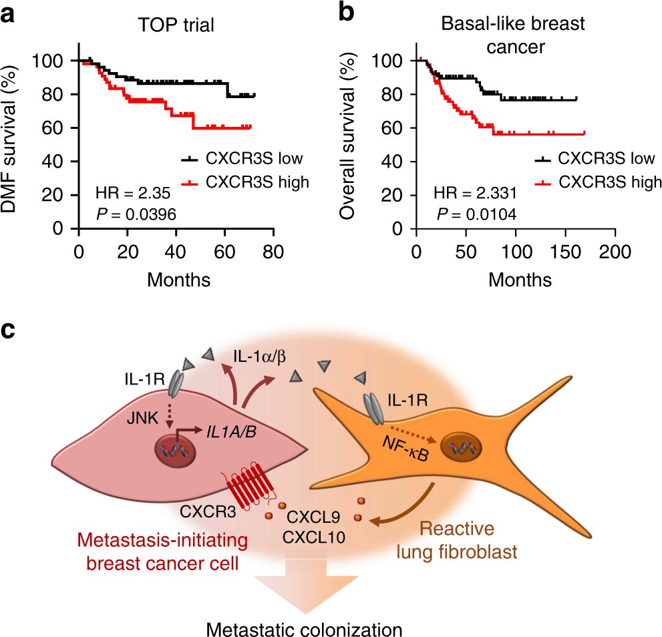然而在 Metastasis-initiating cells induce and exploit a fibroblast niche to fuel malignant colonization of the lungs一文中，他們大致上找出了metastasis-initiating breast cancer cell的啟動模式，如圖一所示，在metastasis-initiating cells中，JNK的high activity會誘發IL-1α/β產生，IL-1α/β又會誘發metastasis-initiating cells進行JNK-related pathway，於是這形成一種autocrine的正回饋使得IL-1α/β levels會不斷增加。當fibroblasts透過IL-1R偵測到IL-1α/β 會引發NF-κB-mediated upregulation of CXCL9/10，CXCL9/10便會促進metastasis-initiating cells表達CXCR3進而導致metastatic colonization。[4]

圖一 Metastasis-initiating breast cancer cell與lung fibroblasts的interaction

此外，在Genomic analysis of metastasis reveals an essential role for RhoC一文，則是以highly metastatic melanoma cells作為模式，並利用DNA array和其他方法確定在highly metastatic melanoma cells中發現small GTPase RhoC的高表現量會促進metastasis，而陰性的Rho或RhoC則都會抑制metastasis的發生，也因此確定RhoC在metastasis是不可或缺的其中一個角色，但確切的機制目前尚未明朗。[5]

**Reference**

[1] Doonan JH, Sablowski R. Walls around tumours - why plants do not develop cancer. *Nat Rev Cancer*. 2010;10(11):794-802. doi:10.1038/nrc2942

[2] Ma, Q., Dai, X., Xu, Y., Guo, J., Liu, Y., Chen, N., Xiao, J., Zhang, D., Xu, Z., Zhang, X., & Chong, K. (2009). Enhanced tolerance to chilling stress in OsMYB3R-2 transgenic rice is mediated by alteration in cell cycle and ectopic expression of stress genes. *Plant physiology*, *150*(1), 244–256. https://doi.org/10.1104/pp.108.133454

[3] Douglas Hanahan and Robert A. Weinberg. (2011). Hallmarks of cancer: the next generation. *Cell.* *144*(5), 646-674.

[4] Maren Pein, Jacob Insua-Rodríguez, Tsunaki Hongu, Angela Riedel, Jasmin Meier, Lena Wiedmann, Kristin Decker, Marieke A G Essers, Hans-Peter Sinn, Saskia Spaich, Marc Sütterlin, Andreas Schneeweiss, Andreas Trumpp, and Thordur Oskarsson. (2020). Metastasis-initiating Cells Induce and Exploit a Fibroblast Niche to Fuel Malignant Colonization of the Lungs. *Nature Communication. 11*(1). 1494.

[5] Edwin A. Clark, Todd R. Golub, Eric S. Lander & Richard O. Hynes. (2000). Genomic analysis of metastasis reveals an essential role for RhoC. *Nature. 406*(6795). 532-535.